- Please refer to GN-XX: Guidance on the Requirements for the Authorisation for the Export of an Unregistered Medical Device which will be Returned After its Refurbishment to the PHMC Licensed Facility for more information on the procedure for import.
- This application is required for an unregistered medical device which is exported to an overseas product owner, manufacturer or their appointed representative for the purposes of refurbishment and subsequent importation into Singapore. The refurbished medical device shall be returned to the original PHMC Licenced facility. The authorisation is solely for the purpose of compliance to Regulation 7 of the Health Products (Medical Devices) Regulations and to facilitate Customs clearance purposes during re-importation.

  - The completed application form and its requisite documents shall be submitted to HSA via email (hsa_md_sa@hsa.gov.sg).

  - The application of for this authorisation shall be made before the device is exported for refurbishment.

- Sections A and B must be completed and duly signed by the licensed importer. The information must be typed or neatly written. The application will be deemed incomplete if any of the sections are not filled in. Incomplete applications will be rejected.

- Section C must be completed and duly signed by the authorized representative of the PHMC.

- Upon the approval of this application, the approval letter would be sent to the licensed importer indicated in section B of Form MDSA-REFURB-01.This approval letter must be presented when the device is re-imported after its refurbishment.

- This approval is provided gratis

- For enquiries, please contact the Medical Device Branch at:-
- telephone number: +65 6866 3560 or
- fax number: +65 6478 9028.
- email: hsa_md_sa@hsa.gov.sg

REPUBLIC OF SINGAPORE  HEALTH SCIENCES AUTHORITY  HEALTH PRODUCTS ACT (No 15 of 2007)  APPLICATION FOR THE APPROVAL OF IMPORT FOR AN UNREGISTERED MEDICAL DEVICE FOR SUPPLY TO PHMC LICENCED FACILITY AFTER ITS REFURBISHMENT FOR THE PURPOSE OF IMPORT DECLARATIONS | 

To be completed by HSA Medical Device Branch:

Approved: Yes No

Our Reference No:

SECTION A MEDICAL DEVICE DETAILS (To be completed by licensed importer)
Device Name (including accessories):

Identifier (e.g. model number) | HS Code | Product Code | Quantity (UOM)
Name and Address of Licenced Importer:

MD Importer Licence Number: | ES
Name and address of product owner: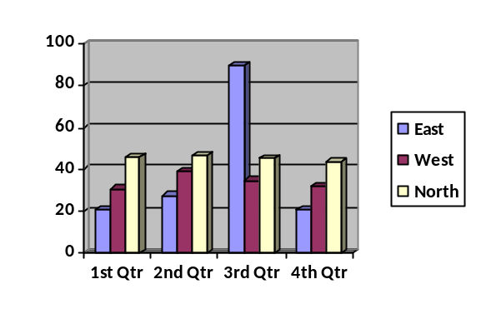

Date or period device will be used:

SECTION B - PARTICULARS OF LICENSED IMPORTER (To be completed by licensed importer)
Name and Address of Importing Company:  Licence Number: ES |  | Name of applicant  (Importing Company):  NRIC/Passport Number:  Designation:  Email:
With reference to the information listed in section A of this form,

I confirm that I am a duly authorised representative of the Company to make this undertaking on behalf of the Company. The Company undertakes to maintain proper records on the import and supply of the medical device.

I declare that this medical device is to be exported to the product owner, manufacturer or their appointed representative, as stated in Section A, for refurbishment

I declare that the medical device will be returned to the PHMC Licenced Facility that owns the medical device (as stated in Section C) after refurbishing and will not be diverted or dispose of.

I undertake to indemnify the government against all actions, claims or proceedings in respect of any adverse event, injury to or death of any person whomsoever arising out of or in connection with the use of the above unregistered medical device.

Date | Signature/company stamp of applicant | Tel: | Fax:

SECTION C - Clinical Laboratory, Medical Clinic or Private Hospital
(To be completed by the Head of Department)

With reference to the information listed in section A of this form,

Reason for Export

Particulars of Authorised Signatory in Clinical Laboratory, Medical Clinic or Private Hospital |  | Full name:  Designation:  Department:  Tel no: Fax No:  Email:
Clinical Laboratory, Medical Clinic or Private Hospital Details  (all fields are to be completed) |  | Name of Hospital/Laboratory:  PHMC Licence Number:  Address:  Tel no: Fax no:
Commercial Name of the Device
Serial Number (where applicable)
Name and address of the organization refurbishing the medical device
With reference to the information listed in section C of this form,

1. I declare that this medical device is to be exported to the product owner, manufacturer or their appointed representatives, as stated in Section C, for refurbishment
2. The device will be returned to us after refurbishing and will not be diverted or dispose of.

Date | Signature and Stamp of Head of Department

